Name:

ID:

Assignment C1-04

Submit assignment here: <https://docs.google.com/forms/d/e/1FAIpQLSfpbnV_mEUXpMgagyrqLIfUtpq4olWAhxrfqjhKx2k-1OaBcA/viewform>

JSFiddle: <https://jsfiddle.net/>

Book: <http://runestone.academy/runestone/books/published/webfundamentals/CSS/toctree.html>

Part 1

1. Consider the following CSS and HTML:

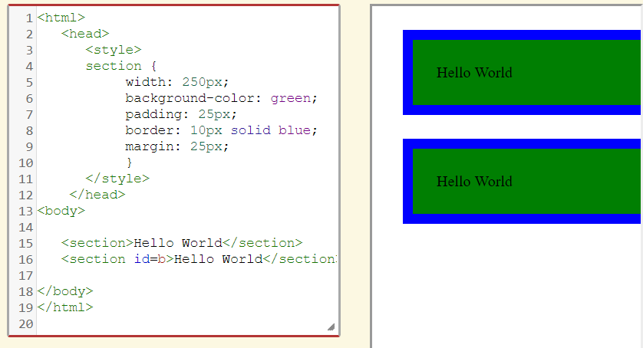

* How can I change the size of the green rectangles?
* What if I want the green rectangles to be gold?
* How can the blue rectangles become smaller and orange?
* How can you increase the space between the rectangles?

1. Consider the following HTML and CSS:

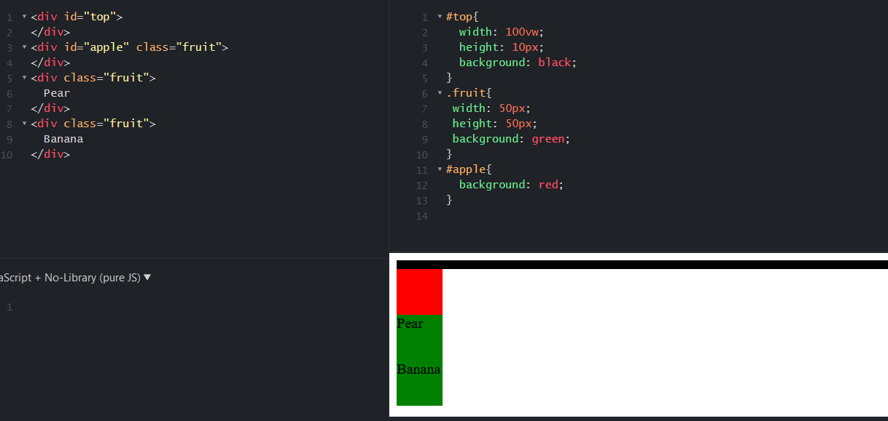

* Change 100vw to 50vw and background: green to background: gold, paste screenshot below:

1. Consider the following HTML and CSS:

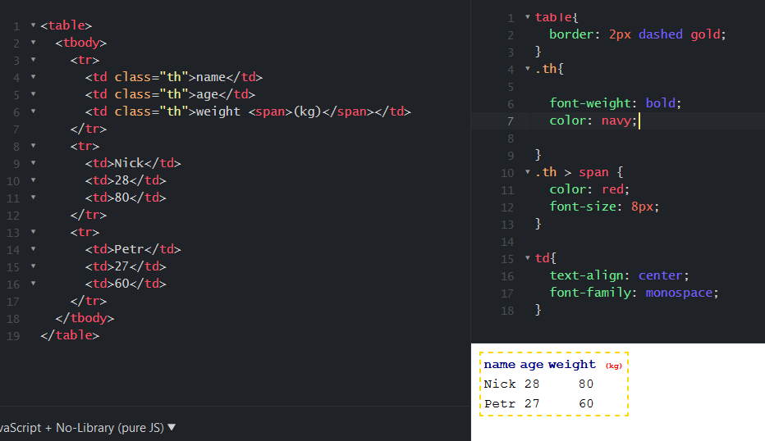

1. Consider the following HTML, JavaScript, and CSS:

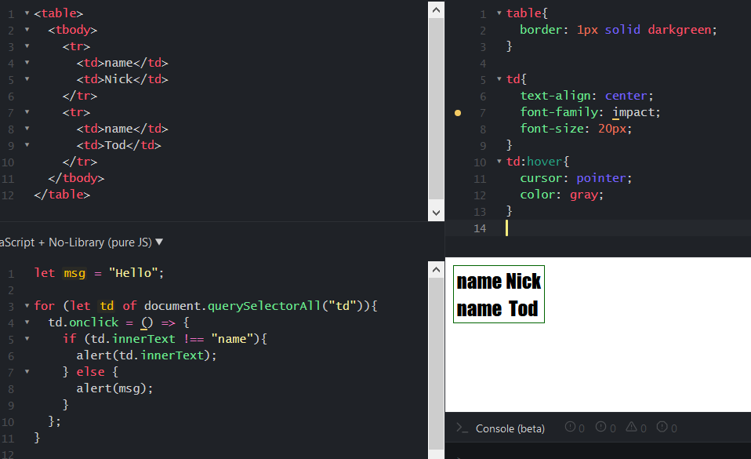

* Change the code so that every time the user clicks name, the alert “freedom” is generated.
* Change the code so that when the user hovers over a td element, the color changes to pink.

1. Consider the following HTML, JavaScript, and CSS:

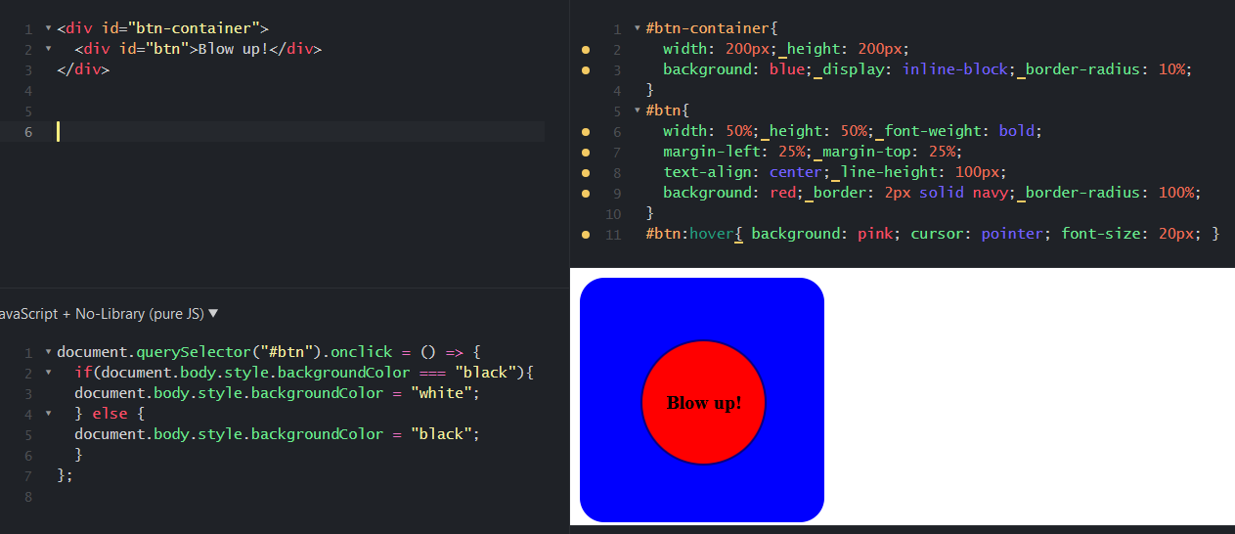

1. Consider the following HTML, JavaScript, and CSS:

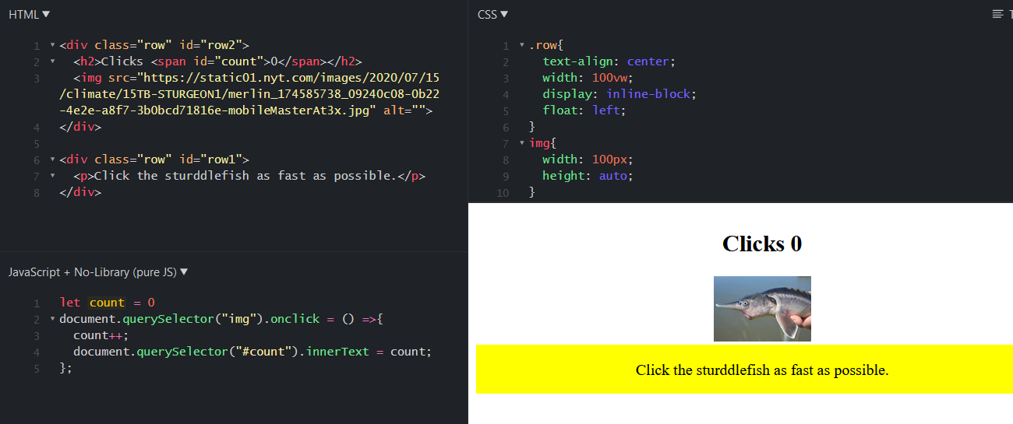

* What happens when you click the sturddlefish?
* Change the code so that count increments by 3 rather than 1:
* What css code is make row1 yellow?

|  |  |
| --- | --- |
| Row{background:yellow;} | .row{background: yellow;} |
| Div{background:yellow} | .div{background:yellow;} |
| #row1{background:yellow;} | #row2{background:yellow;} |

* Change the image of the sturddlefish to an image of a giraffe, paste a screenshot of the output below:

Part 2

1. Create the following with HTML, JavaScript, and CSS. Paste your code below. You can use any image. When you click on the image, an alert box should say “hello”:



1. Create the following with HTML, JavaScript, and CSS. Paste your code below. When you click on one of the black boxes, they should turn red.

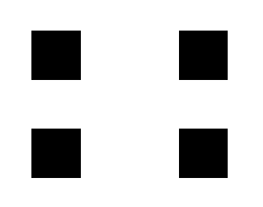

1. Create an unordered list (<ul>) with 3 list items (<li>). The first item should be a hyperlink (<a>) to a website that you like, the second item should be an image (<img>), and the third should be a heading (<h1>) saying your name.